The B&B Section

_____________________________________________________________________________________________

Built with your comfort in mind

Relax and enjoy the peaceful atmosphere and amenities found in our three well finished guest rooms, each with their own spacious ensuite bathroom.
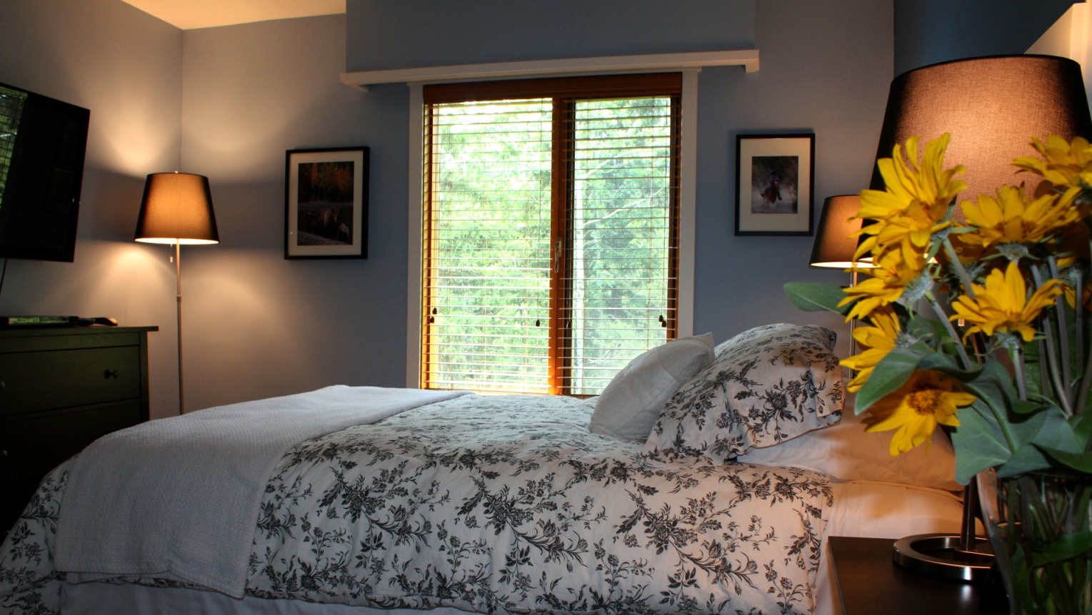
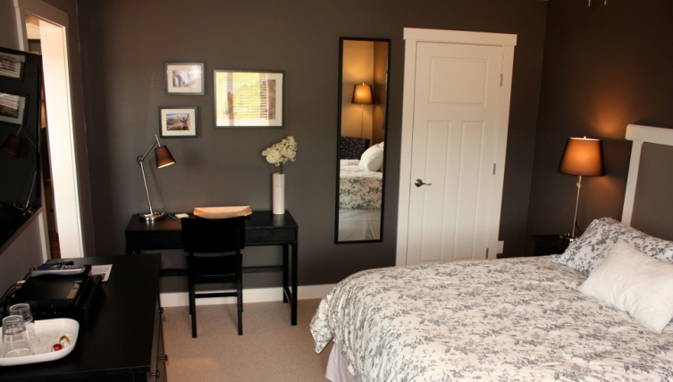
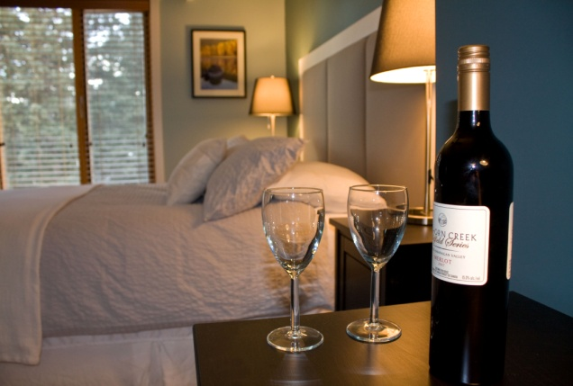
Chase’s Place – standard double, Molly’s Rest – standard queen, The Dukes – deluxe queen,

_____________________________________________________________________________________________

Enjoy the atmosphere of the Parlour

With ample breakfast facilities, a well equipped kitchenette, comfy lounge seating, massive stone fireplace and amazing views over the property.

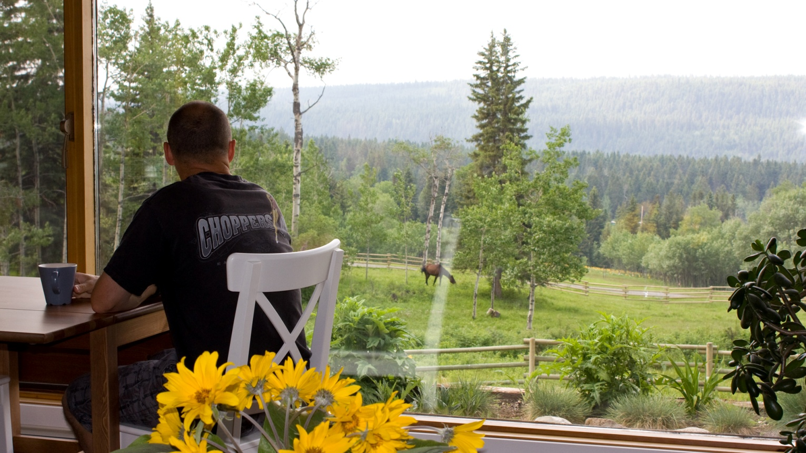

Parlour Images Gallery
(scroll through, right to left, 3 images)

_____________________________________________________________________________________________
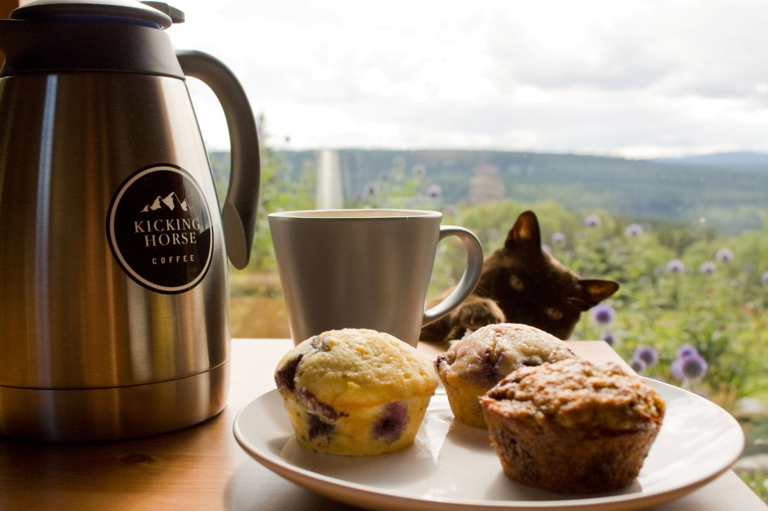
A healthy breakfast
Get a great start to your day with homemade muffins and scones, tasty egg dishes, fresh fruit, yogurt, breads... and of course, lots of coffee.

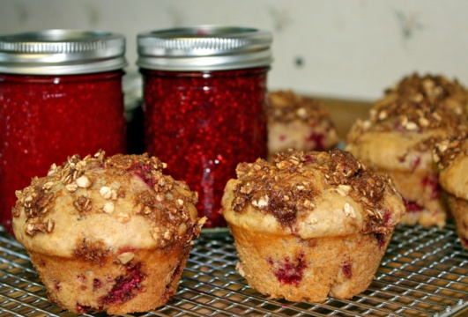
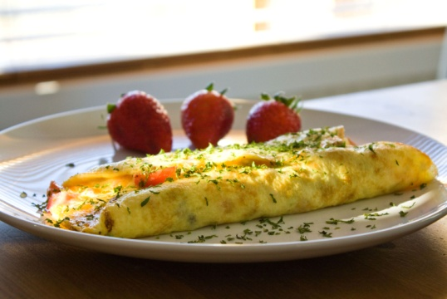
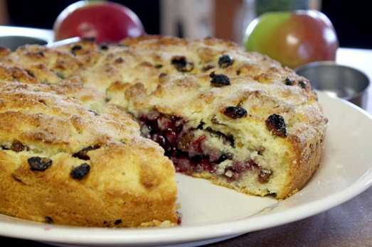
_____________________________________________________________________________________________

Rates

The Dukes, 1 queen bed, ensuite bathroom - $209 CAD per night

Molly’s Rest: 1 queen bed, ensuite bathroom - $199 CAD per night

Chase’s Place: 1 double bed, ensuite bathroom - $189 CAD per night

Popular long weekends in July, August and September, rates are subject to change without notice.

Checkout time is 10 am. Rates are based on double occupancy. Rates are subject to change without notice.
Contact for longer term stays. Government rates are available.

Call, text or email to reserve
1.250.398.8296
Info@junipertrails.ca

Cancellation Policy
A 100% deposit of total stay is required at time of booking for stays of 1 or 2 nights. A 50% deposit of total stay is required at time of booking for stays of 3 nights and longer. Cancellations made 14 days prior to are subject to a $50.00 cancellation fee. Cancellations within 14 days of arrival are charged total for the total reserved stay.

